Coding Assessment

Name: Jeevan Sai Badana

Mail: jeevansai100@gmail.com

Date: 21-02-2024

**Db coding assessment question 3**

**Execute & explain, Azure datafactory and its copy activity.**

**Solution:**

Azure Data Factory (ADF) is a cloud-based data integration service provided by Microsoft Azure. It enables you to create, schedule, and manage data workflows that move and transform data from various sources to different destinations. Azure Data Factory is a fully managed service, meaning that Microsoft handles the underlying infrastructure, scalability, and maintenance, allowing users to focus on building and managing their data pipelines.

One of the key components of Azure Data Factory is the Copy Activity. The Copy Activity is used to move data between different data stores. It supports a wide range of source and destination data stores, including Azure Blob Storage, Azure Data Lake Storage, Azure SQL Database, Azure Synapse Analytics, Amazon S3, Google Cloud Storage, and many more. With Copy Activity, you can perform various data movement operations, such as:

**Data Ingestion:** Copy data from source data stores to Azure or other cloud platforms for further processing and analysis. This could involve moving data from on-premises databases, files, or cloud-based applications.

**Data Loading**: Load data into data warehouses or data lakes for storage and analysis. This could involve loading data into Azure Synapse Analytics, Azure SQL Data Warehouse, or Azure Data Lake Storage.

**Data Replication:** Replicate data between different data stores to maintain data consistency across multiple environments or regions.

**Data Migration:** Migrate data from on-premises data stores to the cloud or between different cloud platforms.

Copy activity in azure takes place as below

First we can create two azure storage accounts one is source storage account which is the data present in it and the another one is the destination storage account which the data is to be copied.

Let’s create the storage accounts first:

Here we create sourcedata1059 storage account for souce and in container we create con1 container and upload some random data

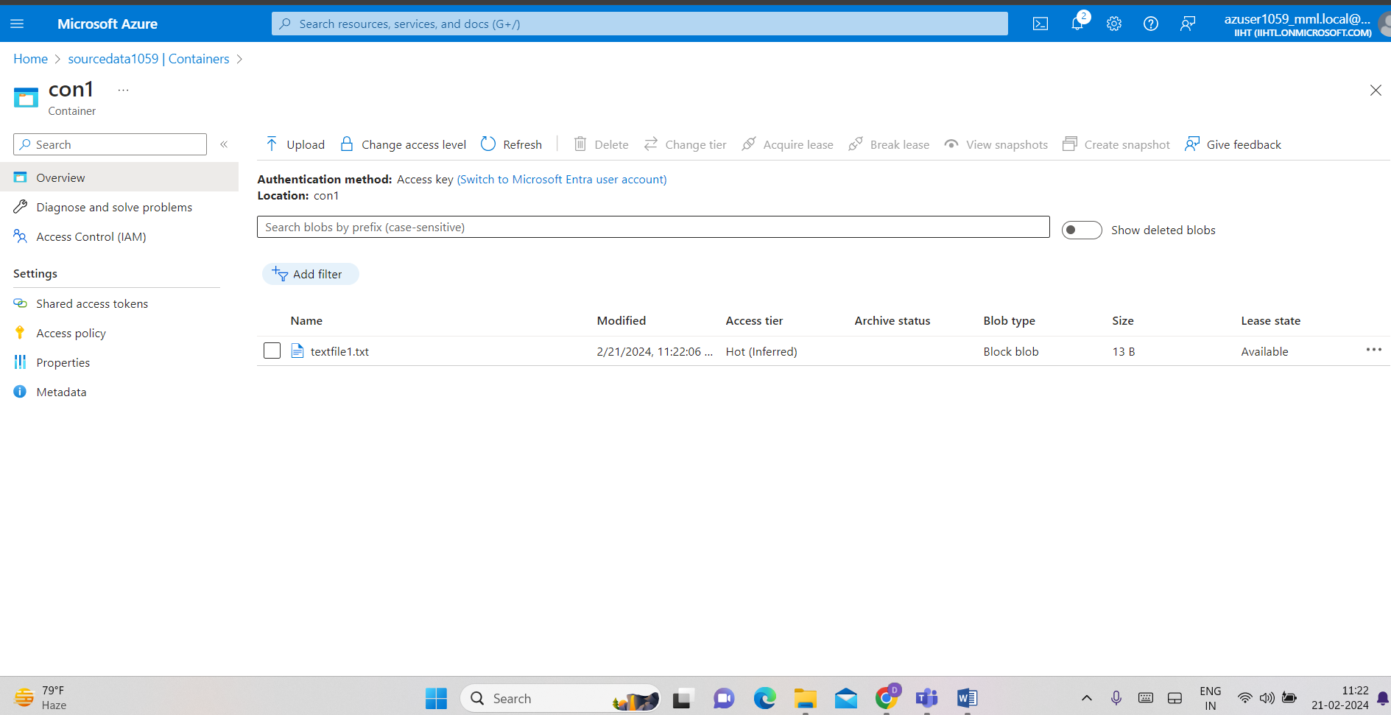

Now we create destination storage account as desdata1059 and in that create a new container con2 and do not upload any data

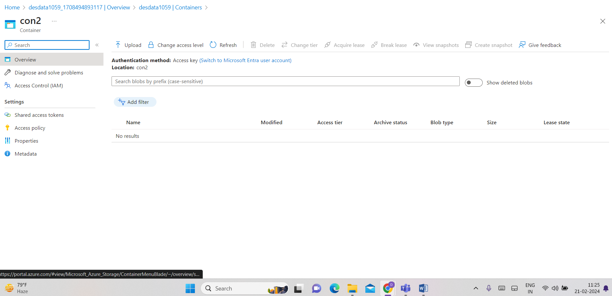

Now we can create jeevandf datafactory

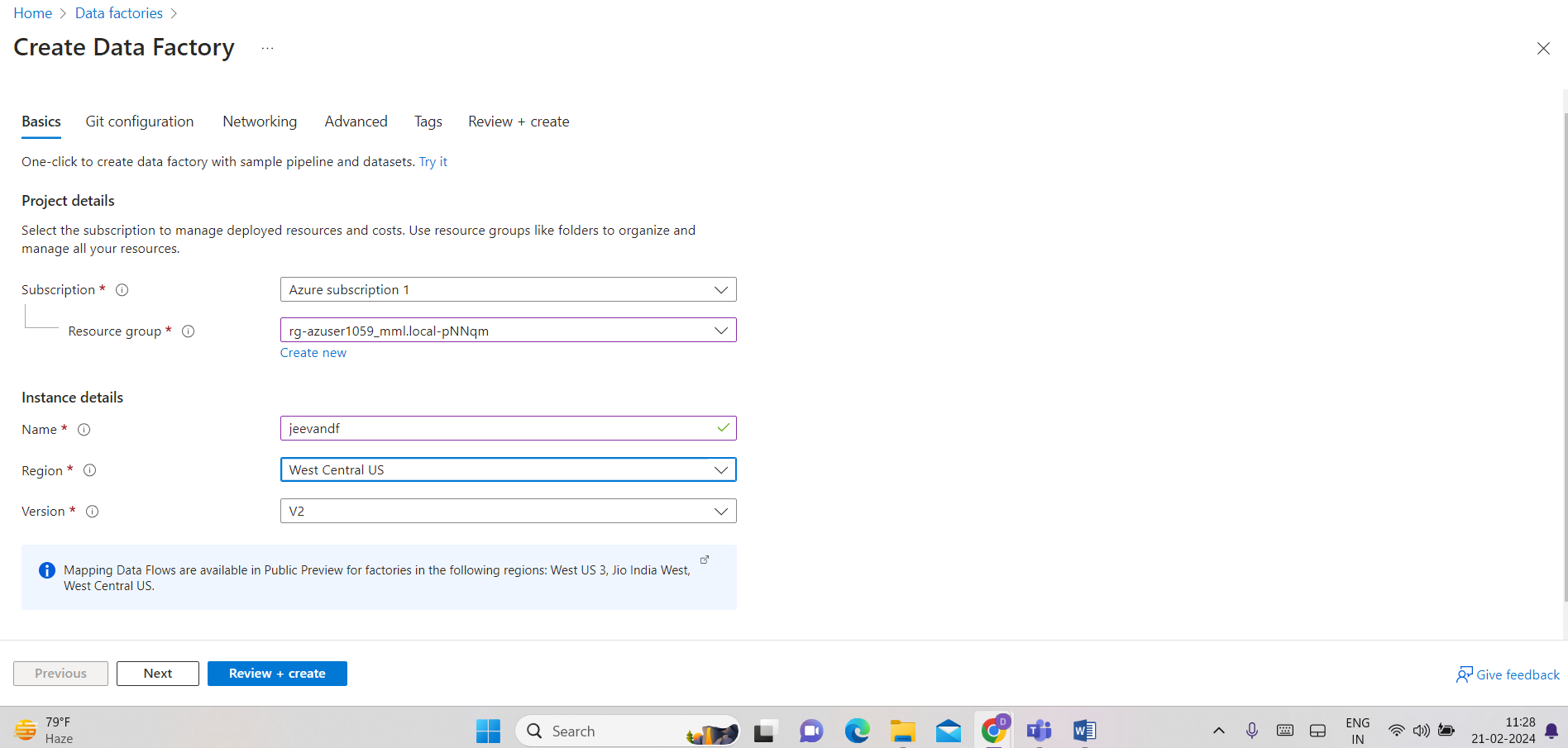

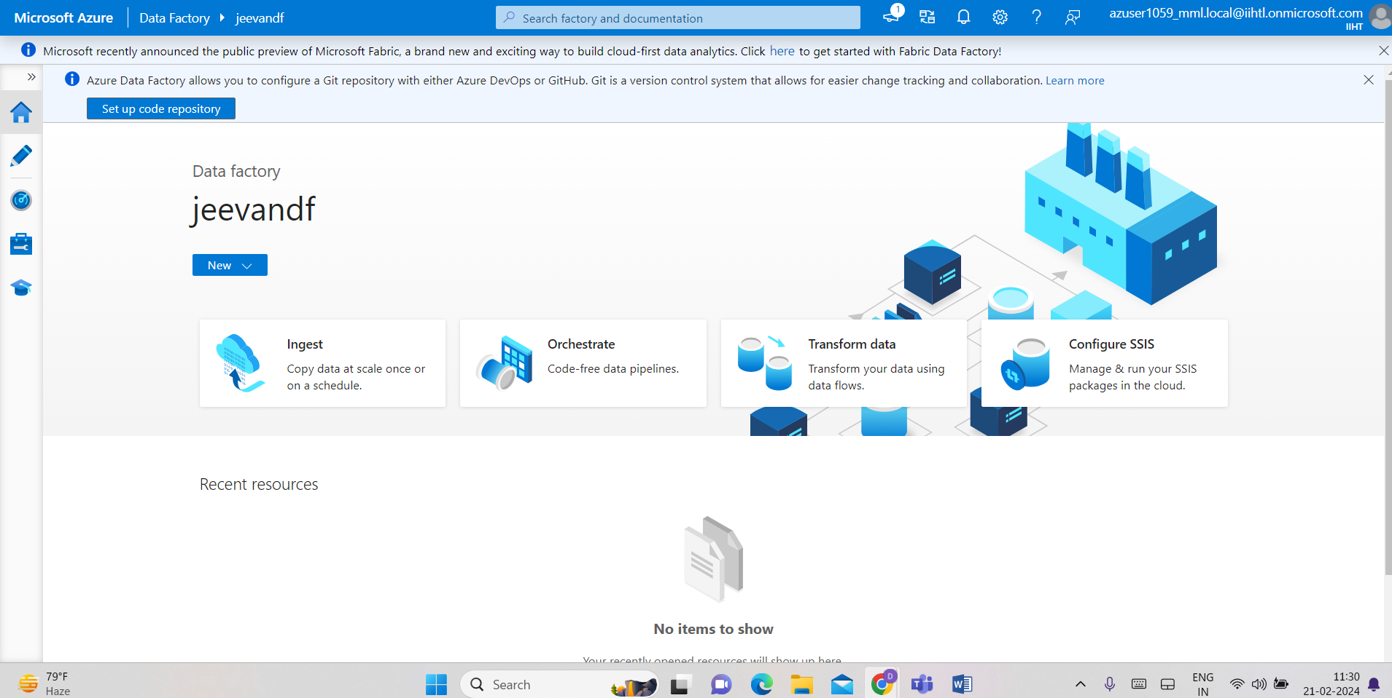

Click on ingest

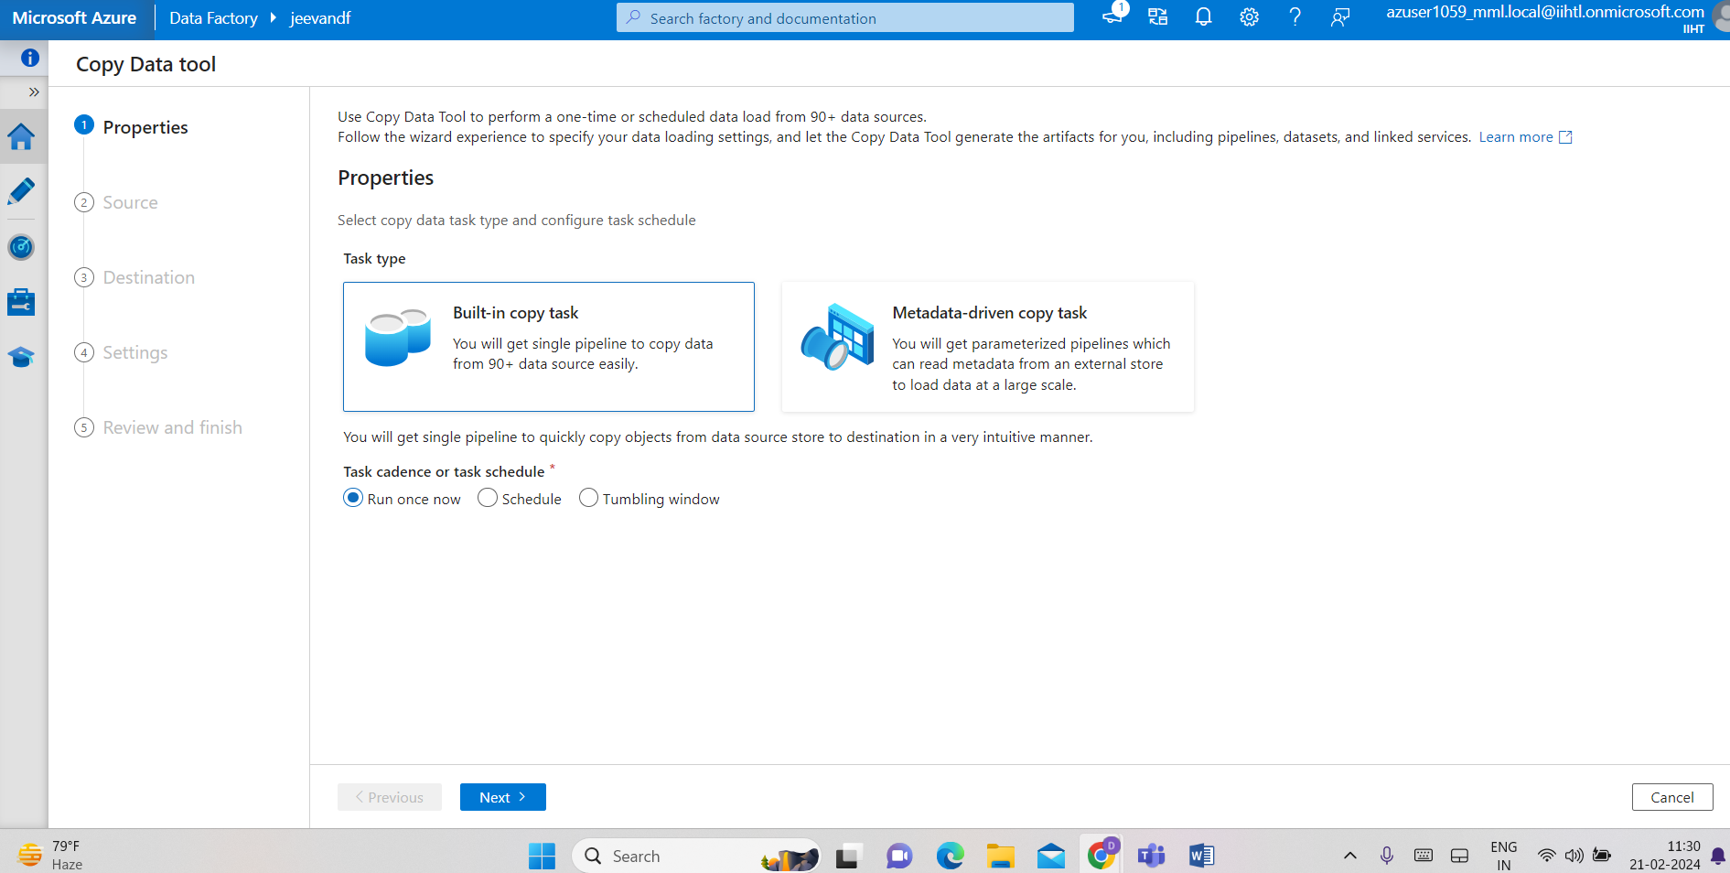

Now we give source data details

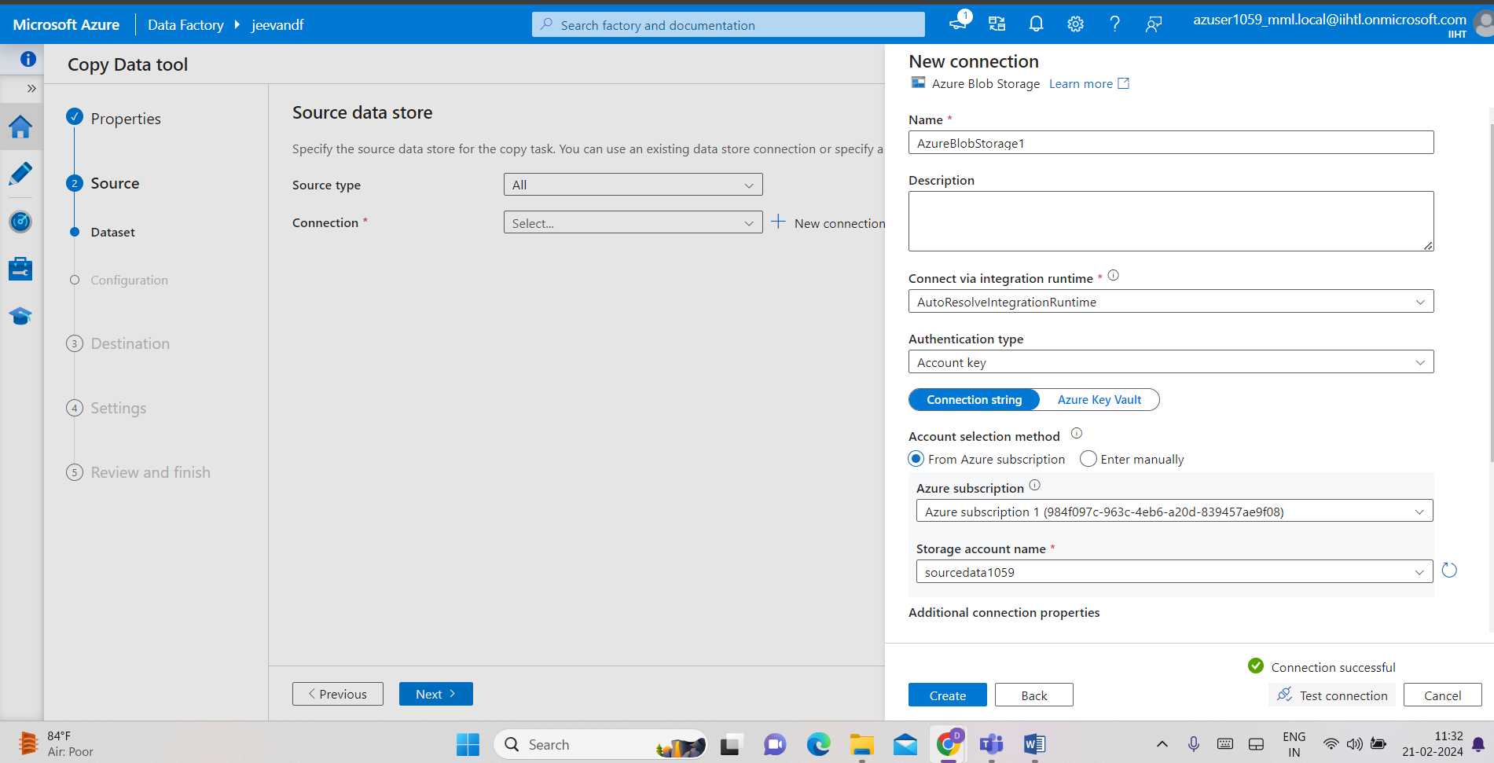



Now give destination details

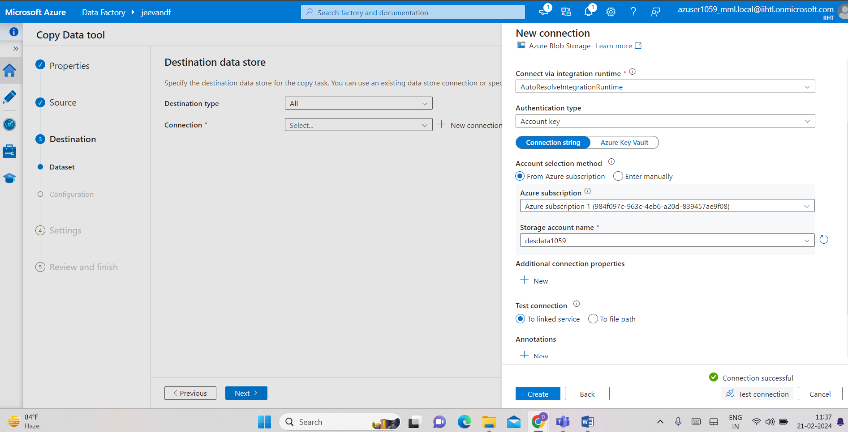

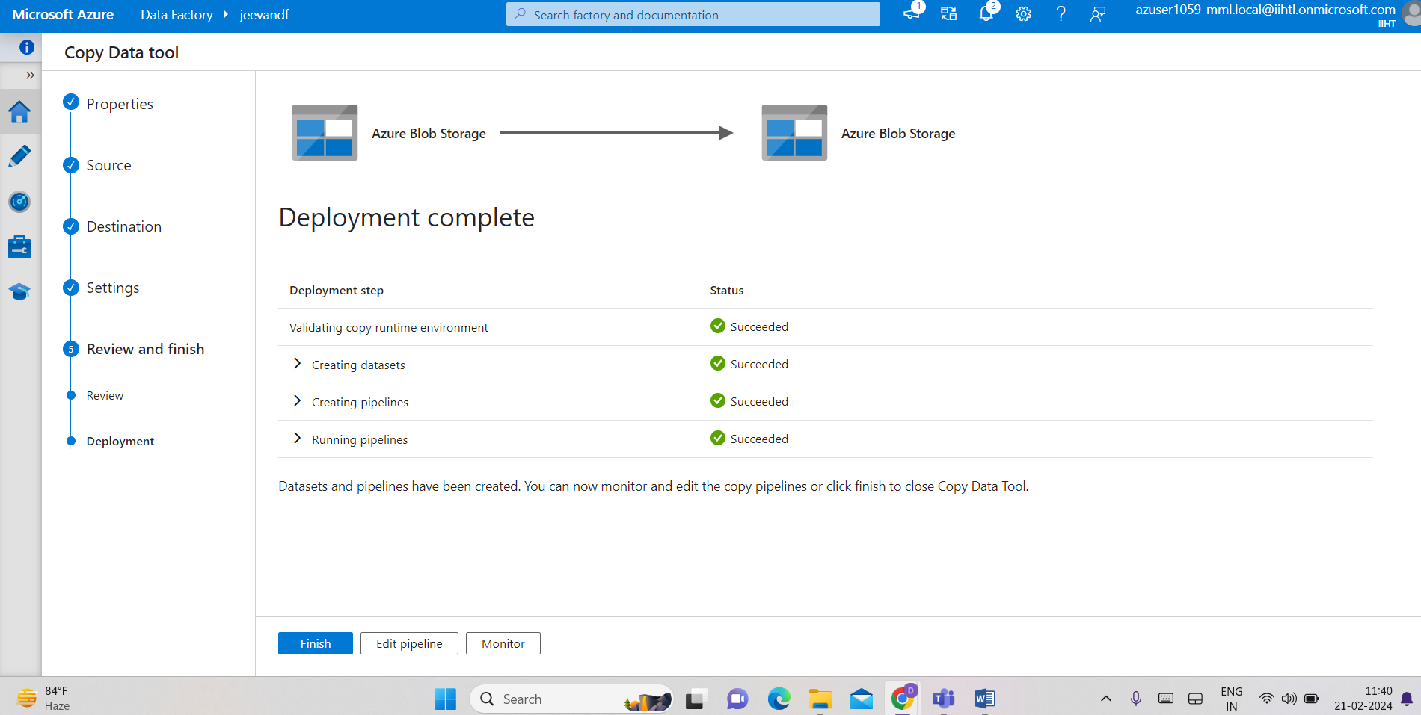

Now we find the copied data in con2 destination data

